**Assignment 11**

**Roll no.: A-44**

**Subject: DAP**

**Code:**

import pandas as pd

import matplotlib.pyplot as plt

from sklearn.cluster import KMeans

data = pd.read_csv("countryClusters.csv")

print(data.head())

plt.scatter(data['Longitude'],data['Latitude'])

plt.xlim(-180,180)

plt.ylim(-90,90)

plt.show()

x = data.iloc[:,1:3]

print(x)

kmeans = KMeans(3)

kmeans.fit(x)

identified_clusters = kmeans.fit_predict(x)

print(identified_clusters)

data_with_clusters = data.copy()

data_with_clusters['Clusters'] = identified_clusters

plt.scatter(data_with_clusters['Longitude'],data_with_clusters['Latitude'],c=data_with_clusters['Clusters'],cmap='rainbow')

plt.show()

wcss=[]

for i in range(1,7):

kmeans = KMeans(i)

kmeans.fit(x)

wcss_iter = kmeans.inertia_

wcss.append(wcss_iter)

number_clusters = range(1,7)

plt.plot(number_clusters,wcss)

plt.title('The Elbow title')

plt.xlabel('Number of clusters')

plt.ylabel('WCSS')

plt.show()

**Output**

Country Latitude Longitude Language

0 USA 44.97 -103.77 English

1 Canada 62.40 -96.80 English

2 France 46.75 2.40 French

3 UK 54.01 -2.53 English

4 Germany 51.15 10.40 German

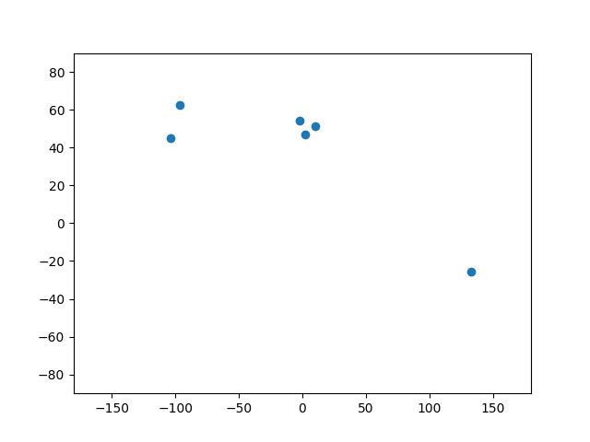

Latitude Longitude

0 44.97 -103.77

1 62.40 -96.80

2 46.75 2.40

3 54.01 -2.53

4 51.15 10.40

5 -25.45 133.11

[2 2 0 0 0 1]

